U Law
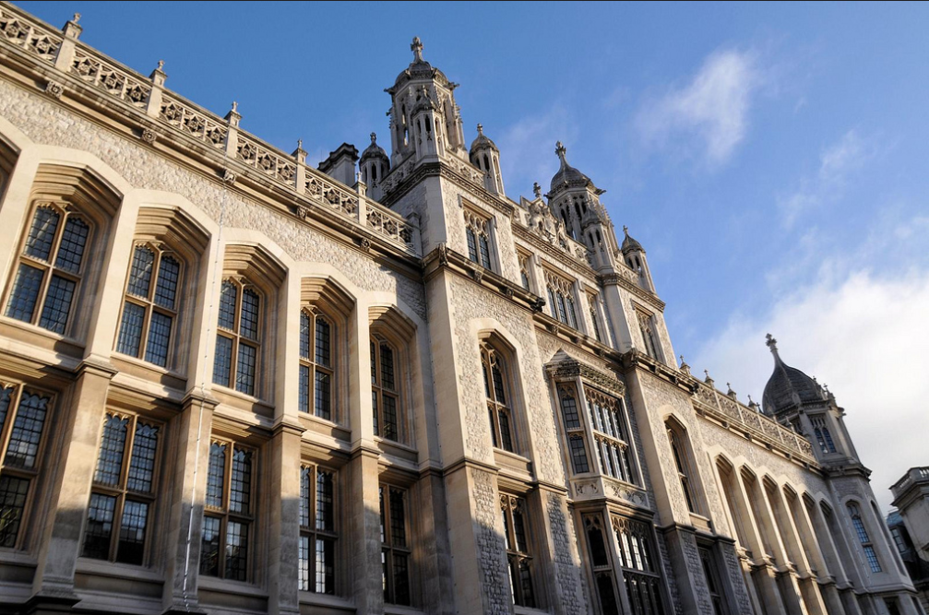Annual Symposium: March 18, 2019
Photo credit: Ian Lee/Flickr
King’s College London – GWU Law
Annual Symposium:
Exclusion and Debarment in Procurement
March 18, 2019
Photo credit: Ian Lee/flickr
Effective international trade in government procurement depends on predictable legal structures, including those that address corruption and misconduct in tender processes. But at this point, the purchaser’s primary tools to maintain integrity -- debarment or exclusion -- remain wildly out of sync on both sides of the Atlantic. This annual free symposium on transatlantic issues in procurement, hosted by King’s College London and George Washington University Law School, will focus on debarment and exclusion, with judges, officials, attorneys and professors from the multilateral development banks, the European Union and the United States joining to discuss the best ways forward to harmonize a common approach to debarment in international trade.

Venue Changed: The Pensions Room, Grays Inn, 8 South Square, London, WC1R 5ET

To reserve your place please book here (required, as spaces are limited)

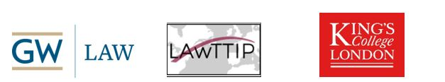

Introductions (10-10:15)
Professor Andrea Biondi & Michael Bowsher QC, King’s College London

Panel I: Establishing and Running an Exclusion System (10:15-11:15)
Moderator: Lisa Miller, Integrity Compliance Officer, World Bank Group
Duc Nguyen, Suspension & Debarment Official, U.S. Environmental Protection Agency (EPA)
Olivier Waelbroeck, European Debarment & Exclusion System (EDES)
Kai Hooghoff, Bundeskartellamt (Federal Cartel Office), Germany
Dominique Casimir, Arnold & Porter

Panel II: Sanctions and Exclusion at the Multilateral Development Banks (11:30-12:30)
Moderator: Prof. Christopher Yukins, George Washington University
Paul Kearney, Chief Counsel & Enforcement Commissioner, EBRD
Collin Swan, World Bank Suspension & Debarment Office
Lisa Miller, Integrity Compliance Officer, World Bank Group

Lunch (12:30-13:30)

Panel III: View from the Private Bar (13:30-14:30)
Moderator: Michael Bowsher QC
Pascal Friton, Blomstein, Berlin
Vera Eiro, Linklaters, Lisbon
John Pachter, Smith Pachter McWhorter PLC, Tysons Corner, Virginia
Paul Khoury, Wiley Rein LLP, Washington, D.C.

Panel IV: Interactions between Public Procurement and Criminal and Civil Claims for Breach of Competition Law and Corruption (14:30-15:30)
Moderator: Professor Renato Nazzini, King’s College London
Professor Alison Jones, King’s College London
Commentator: Eva Anderson, Transparency International
Anna Caroline Müller, World Trade Organization

Tea (15:30-16:00)

Panel V: Judges Panel -- on Competition, Corruption and Procurement (16:00-17:00)

Moderator: Michael Bowsher QC
Professor Carl Baudenbacher, former President of the EFTA Court, Monckton Chambers
Judge Katja Hoegh, Chair, Østre Landsret (High Court of Eastern Denmark), Copenhagen
Justice Helena Rosén Andersson, Swedish Supreme Administrative Court
Judge Marc Steiner, Swiss Federal Administrative Court
Judge Christopher Vajda, Court of Justice for the European Union

The conference will be followed by a reception.

